Project Development Phase
Data Preprocessing Steps
- Data Collection:
- Downloaded the UNESCO World Heritage Sites (2019) dataset in CSV/Excel format from a reliable source.
- Verified dataset completeness and structure.
- Ensured attributes such as:
Site Name, Country, Region, Category (Cultural, Natural, Mixed), Year of Inscription, Latitude & Longitude, Criteria, Area (if available) are properly included.

- Understand the Dataset:
- Identified column names and their meanings.
- Checked data types (numeric, text, date, geographic fields).
- Identified missing values and inconsistencies.
- Reviewed analytical questions such as:
  - Which country has the most heritage sites?
  - What is the distribution of Cultural, Natural, and Mixed sites?
  - How has inscription grown over years?
  - Which region has the highest concentration?

- Import Dataset into Database / Spreadsheet:
- Loaded dataset into Excel / Tableau Desktop.
- Validated successful import of rows and columns.
- Ensured no data truncation or formatting issues.
- Verified geographic roles (Country, Latitude, Longitude).

- Connect Tableau Desktop to Data Source:
- Established connection between Tableau and the UNESCO dataset.
- Verified tables and fields are visible.
- Assigned geographic roles (Country/Region).
- Checked relationships if multiple tables (e.g., region mapping) are used.

- Data Preparation:
Remove Duplicate Records
- Eliminated repeated site entries.
Handle Missing Values
- Replaced null numeric values (e.g., area) with average/median where appropriate.
- Filled missing categorical values (category/region) using standard labels.
Correct Data Types
- Converted inscription year to date format.
- Ensured latitude and longitude are numeric.
- Verified categorical fields (country, region, category).
Data Standardization
- Standardized country names (e.g., USA vs United States).
- Unified category labels (Cultural, Natural, Mixed).
- Standardized regional grouping.
Create Calculated Fields in Tableau
- Total Sites per Country
- Category-wise Site Count
- Year-wise Growth Trend
- Region-wise Distribution
- Percentage of Category Contribution
- Top 10 Countries by Site Count
Filtering & Cleaning
- Removed unnecessary columns (IDs, unused metadata).
- Filtered incomplete or invalid records.
- Removed outlier years (if incorrect entries exist).

- Data Validation:
- Cross-checked total number of UNESCO sites (2019).
- Validated country-wise totals with source data.
- Ensured no null values affecting map visualization.
- Verified calculated fields produce correct results.

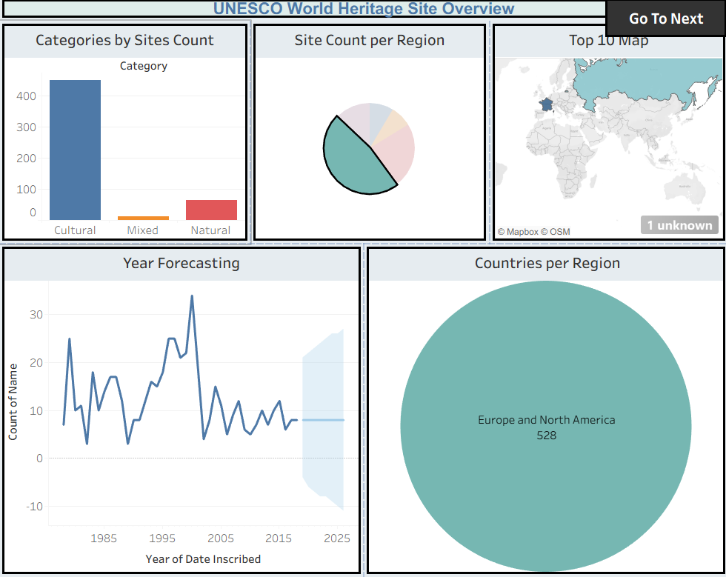
Dashboard 1
Dashboard 2

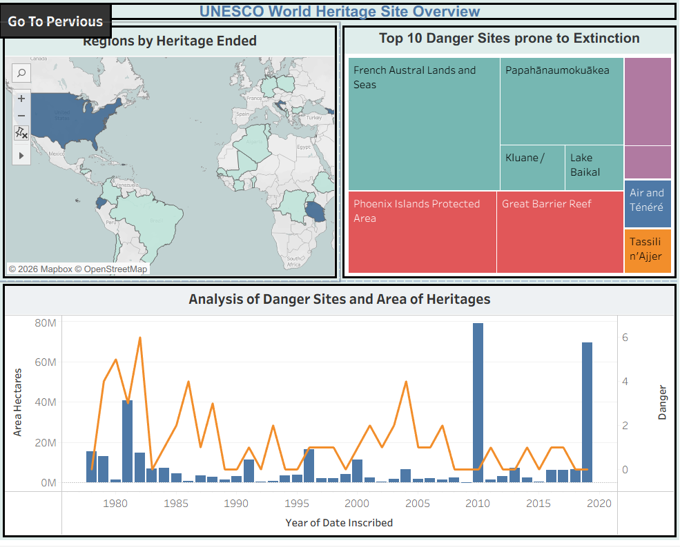

Story
